**A project on**

**Social media app using ReactJS, NodeJS and mysql**

**Submitted by:**

**Prajapati Ashishkumar Dharmendrabhai**



**Pro: Mrs.Hemali Patel**

**Submitted to:**

**Matrushri L.J Gandhi BCA College Modasa**

**College Campus,Modasa**

**Managed By: The M.L Gandhi Higher Education Society, Modas**

**Matrushri L.J Gandhi (Bakorvala) B.C.A &**

**Dr.N.J Shah P.G.D.C.A College ,Modasa**

**Affiliated with Hemchandracharya North Gujarat University, Patan.**

**CERTIFICATE**

**This is to certify that:-**

**Mr. Prajapati Ashishkumar Dharmendrabhai**

**Enrollment Number:-** **BCA29921008512**

**Is a student of Sem-VI Bachelor of Computer Application (BCA) During**

**academic year 2023-2024 in Matrushri L.J Gandhi(Bakorvala) B.C.A &**

**Dr.N.J.Shah P.G.D.C.A College, Modasa**

**He developed Project on**

**social media app using Reactjs, Nodejs and mysql**

**Matrushri L.J Gandhi (Bakorvala) B.C.A**

**&**

**Dr.N.J .Shah P.G.D.C.A College,Modasa..**

**The duration of the project is 50 days.**

**The System is Verified by as and found suitable for implementation at the Firm/ Institute.**

**During project work ,he was sincere and regular..**

**[project coordinator] [principle]**

**Mrs. Hemalipatel Dr.J.H.Trivedi**



**Managed By: The M.L Gandhi Higher Education Society, Modas**

**Matrushri L.J Gandhi (Bakorvala) B.C.A &**

**Dr.N.J Shah P.G.D.C.A College ,Modasa**

**Affiliated with Hemchandracharya North Gujarat University, Patan.**

## ABSTRACT

SocialShare is a web-based social media application built using ReactJS, Node.js, and MySQL. It allows users to create profiles, connect with friends, share posts, and interact with each other's content.

**Key functionalities:**

* User Management: Registration, login, profile creation, and profile editing.
* Social Interactions: Sharing text and media posts, liking and commenting on posts, following other users.
* Data Persistence: MySQL database stores user information, posts, comments, and relationships.
* Front-end Development: ReactJS provides a dynamic and interactive user interface.
* Back-end Development: Node.js serves as a robust server with APIs to handle user requests and interact with the database.

**Benefits:**

* User-friendly interface with ReactJS.
* Scalable and secure backend with Node.js.
* Efficient data storage and retrieval with MySQL.
* Encourages social interaction and content sharing.

**Chapter 1: Introduction**

1. **INTRODUCTION**

SocialShare – an innovative social media application built on the cutting-edge technologies of ReactJS, NodeJS, and MySQL. SocialConnect is designed to provide users with a vibrant and interactive platform for connecting, sharing, and communicating in the digital space.

In this doc file, you will find detailed insights into the features, functionalities, and technical aspects of socialShare, empowering developers, administrators, and users to navigate and utilize the application effectively. Whether you are looking to integrate SocialShare into your existing project, deploy it on your servers, or simply explore its capabilities, this documentation serves as your go-to resource.

Our intuitive interface, powered by ReactJS, allows you to navigate and interact with ease. Create a profile, connect with friends, share posts, and engage with content – all with just a few clicks.

Share your thoughts, experiences, and creativity with the world! SocialShare allows you to write text posts and even explore future options for richer content sharing through images and videos.

Built with Node.js on the backend, SocialShare guarantees a robust and secure platform that can grow with our expanding community.

Visual Studio code used in this project for all the code writing. Also used technologies such as bcryptjs for Hashing user passwords for better security

## PRESENT SYSTEM

The current system focuses on building a solid foundation for user interaction and content creation. It utilizes the following technologies:

* **Front-end:** ReactJS provides a dynamic and user-friendly interface for profile creation, post creation (text-based), and basic social interactions like following friends, liking, and commenting on posts.
* **Back-end:** Node.js serves as the server platform with RESTful APIs to handle user requests, user authentication, and interaction with the database.
* **Database:** MySQL stores user data, post information (text content), comments, and follower relationships. This ensures secure data storage and retrieval.

**Current functionalities:**

* User Management: User registration, login, profile creation, and basic profile editing.
* Social Interactions: Sharing text posts, liking and commenting on posts, following other users for updates on their activity.

## PROPOSED SYSTEM

Building upon the core functionalities, SocialShare has ambitious plans for the future, aiming to offer a richer and engaging social media experience:

* **Front-end Enhancements:**
  + Integrate functionalities for uploading images and videos to posts, allowing for more diverse content sharing.
  + Explore implementing real-time features like live chat functionalities for enhanced interaction.
* **Back-end Development:**
  + Develop features like private messaging for one-on-one communication.
  + Integrate notification systems to keep users informed about new messages, comments, and activity from their network.
* **Database Enhancements:**
  + The database schema may need to be expanded to accommodate richer content types like images and videos.
  + Implement functionalities for efficient storage and retrieval of multimedia content.

**Proposed functionalities:**

* Richer Content Sharing: Allow users to share images and videos alongside text posts for a more engaging experience.
* Enhanced Social Interactions: Implement private messaging, group creation, and notification systems to facilitate deeper connections and communication.

# Chapter 2:System Design

### 2.1.DATAFLOW

Start - **Login or Register page will open**

Input - **After logging Successfully, users can see their posts as well as their friends' posts. user can post, like and comment under the post**

Perform - **users can follow other users also. they can change their profiles according to their needs**

Exit - **Logged out successfully**

# Chapter 3:Software Details

The IDE used in this project is Visual Studio Code. All the React files were created vs code and all the necessary packages were easily installable in this IDE. For this project the following modules and libraries were used i.e. reactjs DOM, react router, Datetime, Google search, yarn(package manager) etc.

## Visual Studio Code

VS Code is a versatile and powerful source code editor that caters to the needs of programmers of all levels. Its extensive features, customizability, and large community make it a popular choice for web development, application development, and various other coding tasks.

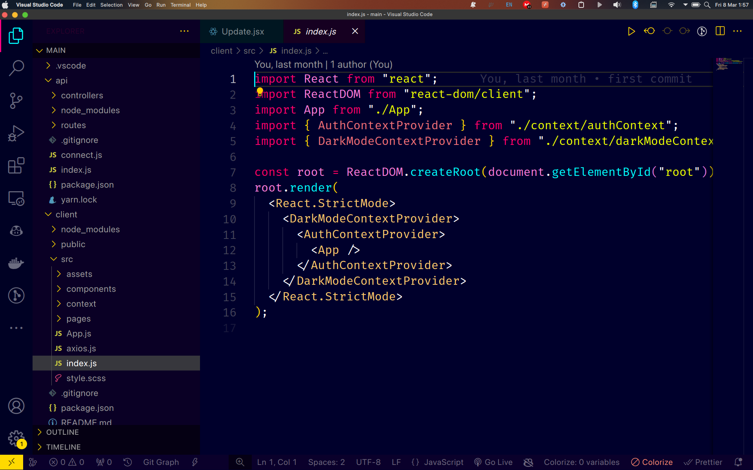

**Figure3. Vs code**

## 3.2 Other Technologies used for this project

**3.2.1 Reactjs:** A javascript library used to build web apps easily.

**3.2.2 ReactDOM:** React DOM is a library specifically designed for working with the Document Object Model (DOM) within React applications

**3.2.3 ReactRouter:** React Router is a popular library for managing navigation and routing within React applications. It allows you to define different routes (URLs) that map to specific components in your application.

**3.2.4 scss:** SCSS, which stands for Sass (Syntactically Awesome Style Sheets), is a preprocessor scripting language for CSS.

**3.2.5: Yarn:** Yarn is a popular package manager specifically designed for the JavaScript runtime environment Node.js.

**3.2.6 Nodejs:** Node.js is an open-source, cross-platform JavaScript runtime environment that executes JavaScript code outside of a web browser.

**3.2.7 Express Js:** Express.js is a popular web application framework built on top of Node.js

**3.2.8 MySql:** MySQL is a popular open-source relational database management system (RDBMS) developed by Oracle.

# Chapter 4:Implementation Work Details

SocialShare is a web-based social media application built using ReactJS, Node.js, and MySQL. It allows users to create profiles, connect with friends, share posts, and interact with each other's content.

## REAL LIFE APPLICATION

* + 1. **Marketing and Promotion:** Businesses can use SocialShare to promote their products, services, and brand to a wider audience. They can share engaging content, run social media campaigns, and interact with potential customers directly.
    2. **Customer Engagement:** SocialShare can be a valuable tool for customer engagement. Businesses can use it to provide customer support, answer questions, and build relationships with their customers. They can also leverage social listening to understand customer sentiment and improve their offerings.
    3. **Employee Advocacy:** SocialShare can be used to encourage employee advocacy. Businesses can create a platform where employees can share company news, blog posts, and other positive content about their workplace. This can help attract new talent and build a strong employer brand.
    4. **Events and Networking:** SocialShare can be used to promote events, conferences, or workshops organized by businesses or organizations. They can also use it to facilitate networking among attendees and create a buzz around the event.

## DATA IMPLEMENTATION AND PROGRAM EXECUTION

As the first step, install all the necessary packages and libraries.First of all install the necessary libraries.Open your terminal(for windows users it is windows terminal) and type “yarn” to install all the necessary libraries. The necessary packages are as follows:

* + 1. **LIBRARIES AND PACKAGES**

**4.2.1.1 Reactjs:** A javascript library used to build web apps easily.

**4.2.1.2 ReactDOM:** React DOM is a library specifically designed for working with the Document Object Model (DOM) within React applications

**4.2.1.3 ReactRouter:** React Router is a popular library for managing navigation and routing within React applications. It allows you to define different routes (URLs) that map to specific components in your application.

**4.2.1.4 scss:** SCSS, which stands for Sass (Syntactically Awesome Style Sheets), is a preprocessor scripting language for CSS.

**4.2.1.5: Yarn:** Yarn is a popular package manager specifically designed for the JavaScript runtime environment Node.js.

**4.2.1.6 Nodejs:** Node.js is an open-source, cross-platform JavaScript runtime environment that executes JavaScript code outside of a web browser.

**4.2.1.7 Express Js:** Express.js is a popular web application framework built on top of Node.js

**4.2.1.8 MySql:** MySQL is a popular open-source relational database management system (RDBMS) developed by Oracle.

# Chapter 5:Source CodeandCommands

**Chapter 6: Input/Output Screenshot**

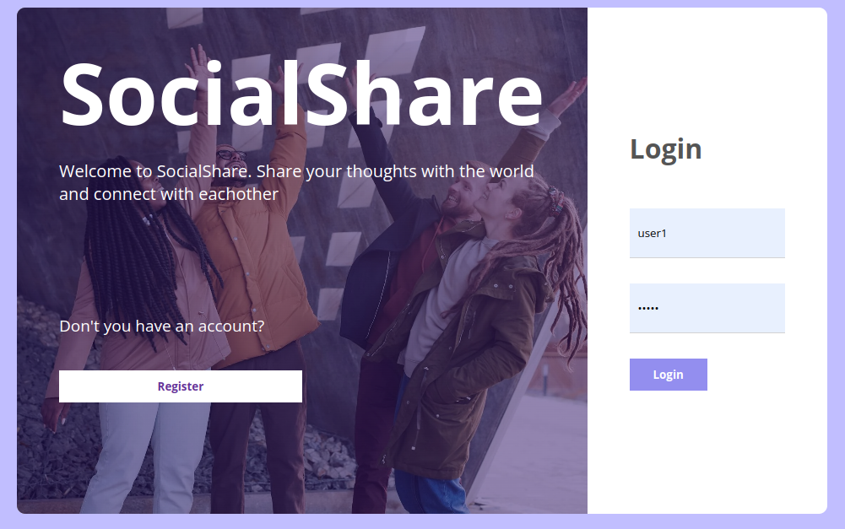

**Figure 6.1 Login Page**

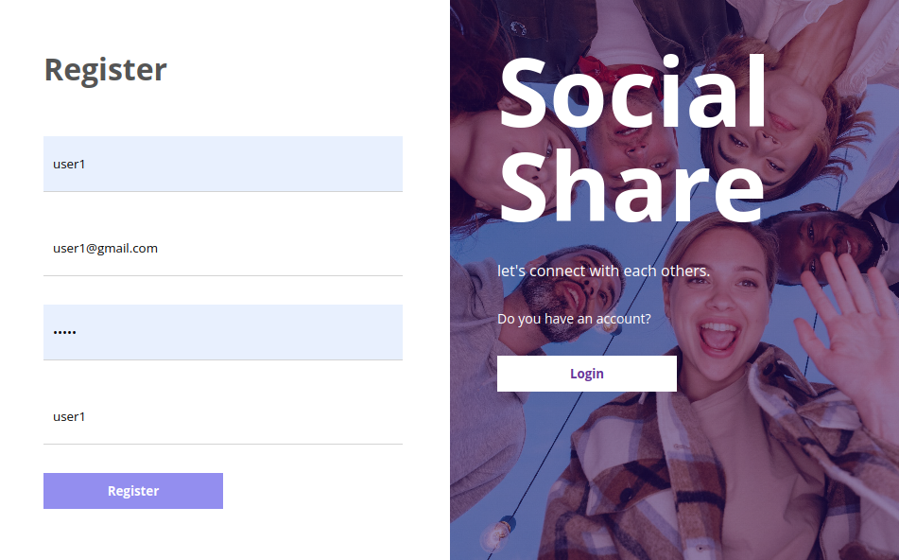

**Figure 6.2 user Registration page**

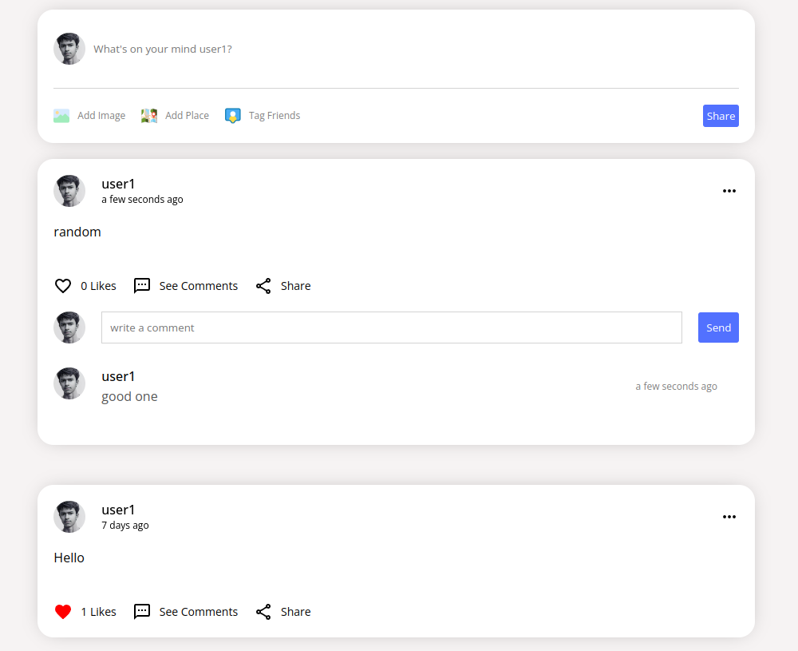

**Figure 6.3 User interaction**

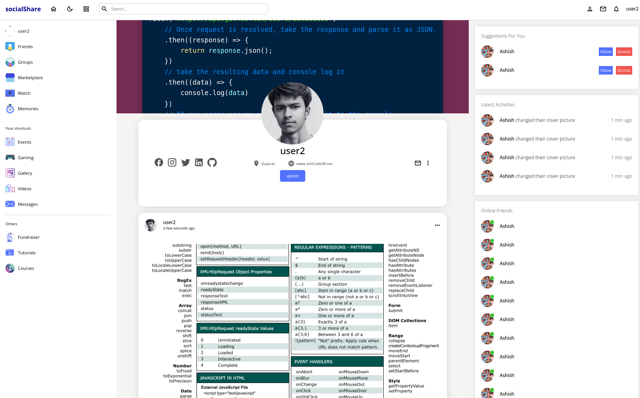

**Figure 6.4 User Profile Section**

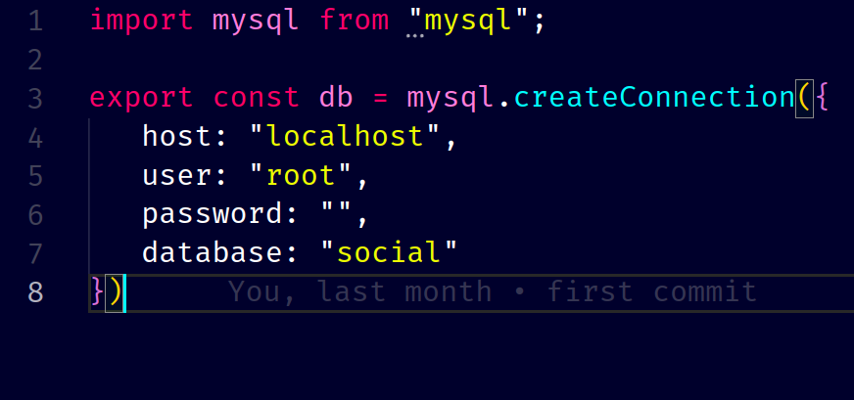

**Figure 6.5 Database Configuration**

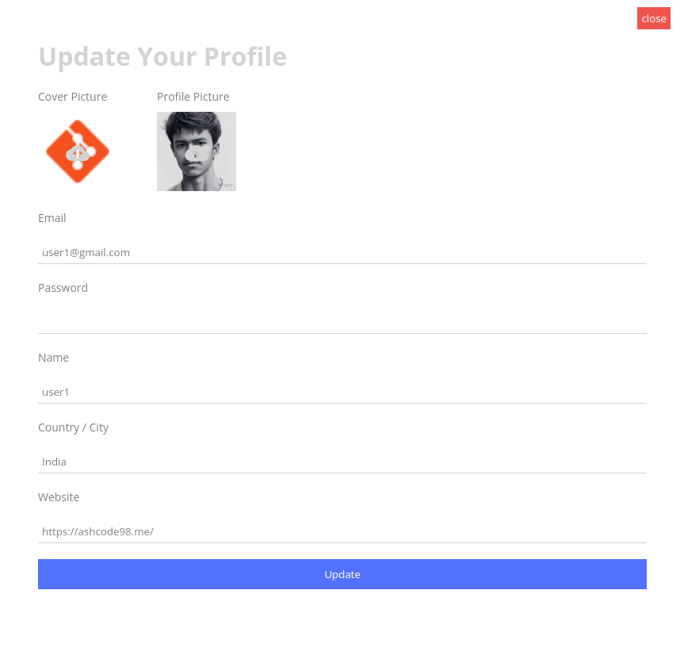

**Figure 6.6 Profile Update**

# Chapter 7:System testing

The system testing is done on a fully integrated system to check whether the requirements are matching or not. The system testing for SocialShare is done by following four parameters:

## FUNCTIONALITY

In this we check the functionality of the system whether the system performs the task which it was intended to do. To check the functionality each function was checked and run, if it is able to execute the required task correctly then the systempasses in that particular functionality test. For example to check whether the user can post their image or something else or not, as we can see in the figure 7.1, the user posted an image and someone liked this posts and comment under the post



**Figure 7.1 user Post functionality**

## 7. 2 USABILITY

* **Simple Post Creation:** Sharing content should be effortless. Intuitive interfaces for text, photo, and video uploads (if applicable) will streamline the content creation process.
* **Clear Editing Options:** Users will have easy access to editing tools for their posts, allowing them to adjust captions, tag friends, and customize privacy settings.
* **Clear Like and Comment Functionality:** Lively and easily identifiable buttons for liking and commenting will encourage user interaction and engagement with content.
* **Real-time Updates:** Users will be notified about new messages, comments, and mentions in real-time (if applicable) to keep them engaged and informed.
* **Customization Options:** Allow users to personalize their experience to some extent. This could include profile picture customization, notification preferences, or interface theme options.

## 7. 3 SECURITY

* **Secure Login:** We will implement strong password hashing techniques to protect user credentials. Additionally, two-factor authentication (2FA) will be offered as an optional layer of security for logins.
* **Authorization Levels:** User roles and permissions will be clearly defined. This ensures that users can only access and modify information they are authorized to, preventing unauthorized access to sensitive data.
* **Session Management:** Secure session management practices will be followed to prevent unauthorized access to user accounts after successful login.

## 

## 7. 4 STABILITY

At SocialShare, stability is a cornerstone of our development process. We prioritize building a robust and reliable platform that can handle user growth and varying usage patterns.

# Chapter 9:Conclusion

SocialShare aspires to become a leading player in the social media landscape. We believe in the power of connection and aim to foster a platform that prioritizes user experience, stability, and continuous innovation.

## LIMITATIONS

* + 1. Security is somewhere an issue, there is potential risks for user credentials
    2. users should be aware of the potential risks associated with sharing data online
    3. Social media can be addictive and consume excessive amounts of time
    4. SocialShare strives to create a positive and enriching social media experience. However, it's important to acknowledge these limitations and empower users to navigate the platform responsibly and safely

## SCOPE FOR FUTURE WORK

* + 1. Can add more functionalities such as video streaming.

9.2.2 making more interactive and responsive for users according to their feedbacks

9.2.3 will try to change some of the minor details